**Evaporative air cooling unit (air cooling)**

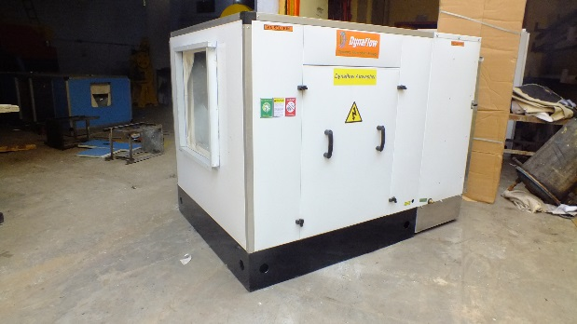 ECU ( ECONOMY )

Single skin with Indian blower

Rang 1500cfm to 50000cfm

ECU (deluxe )

Double skin with imported make blower

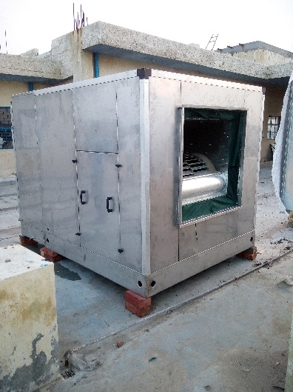Rang 1500cfm to 50000cfm

ECU –SS

Stainless steel casing

Rang 1500cfm to 50000cfm

ECU- double stage

Range 1500cfm to 50000cfm

ECU – TWIN BLOWER

Economy & deluxe model

Rang 10000cfm to 1,00,000cfm

Spray type air washer

Rang 10000cfm to 50000cfm